MedRec

A novel design feature of MedRec is the way records are validated and added to the blockchain. The miners for MedRec are medical researchers who are rewarded with access to census-level data of the medical records. Similar to the census, the individual privacy of the person is protected, and the aggregate data is used for critical research. In essence, this is both a medical research blockchain, and a clinical one.

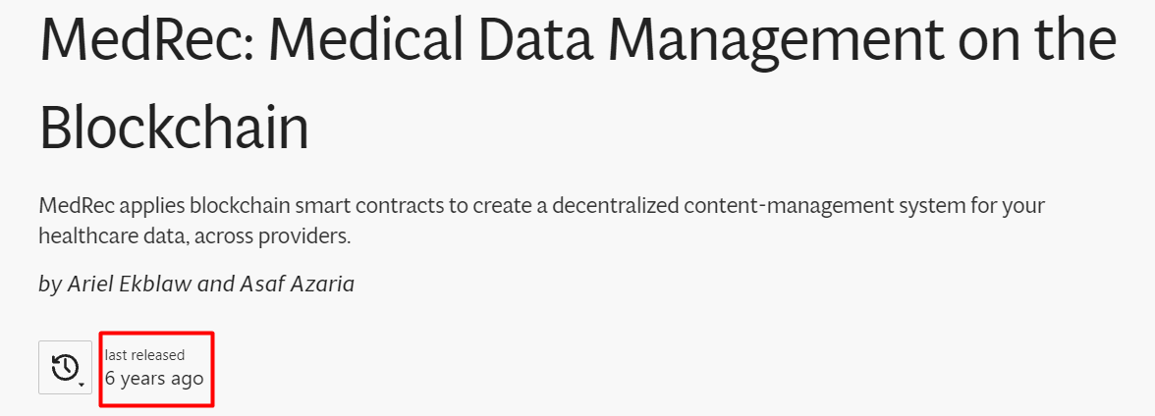



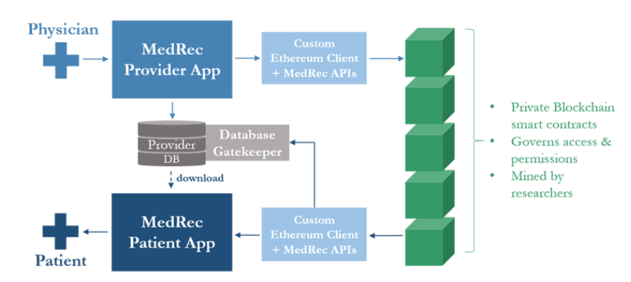

This use case example begins with a physician adding a new record through the MedRec Provider App. The record information is stored in the Provider's existing database system, and a hashed reference to the data (with appropriate viewing permissions) is posted to the blockchain through our Ethereum client and library of backend APIs. The patient can retrieve and download this data from the provider's database, after the database gatekeeper checks the blockchain to confirm their access and ownership rights.

**Decentralization**

Our blockchain implementation gives us several key properties of decentralization. The MedRec protocol enjoys a strong fail-over model, relying on the many participating entities in the system to avoid a single point of failure: medical records are stored locally in separate provider and patient databases; copies of authorization data are stored on each node in the network. Furthermore, because the medical data stays distributed, our system does not create a new, central target for content attack

<https://github.com/l-aleksashka-l/medrec>

<https://dlt4all.eu/medrec/>